Escape the Dungeon

Overview:

Objective:

* Escape the dungeon as fast as possible by solving riddles and problems. Riddles are found in chests throughout each level and can help unlock new passages. If questions are answered incorrectly, lives are lost. User starts with 5 lives.
* Based on escape room puzzle concept

How to run program:

1. Open “FBLA Game-Escape the Dungeon” folder
2. Run “FBLA Game.exe”

Interface:

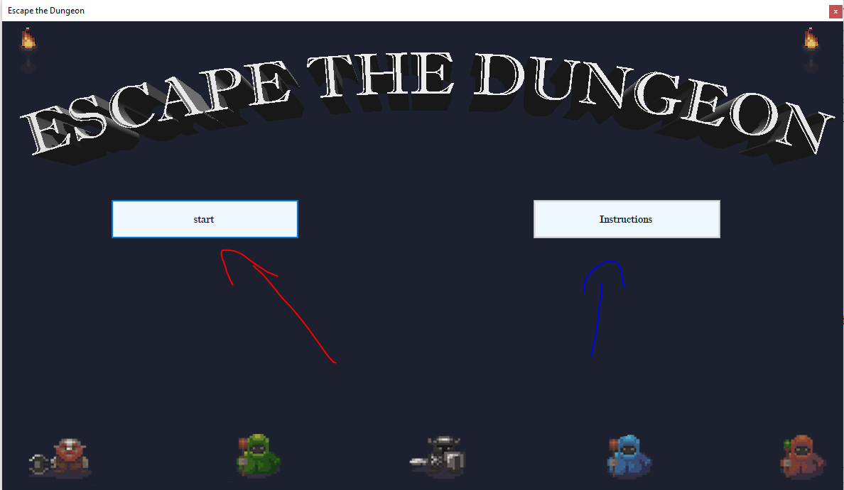

Figure 1. Main Menu

Click either “start” button to navigate directly to level 1 of escape room or click “Instructions” to navigate to instructions page:

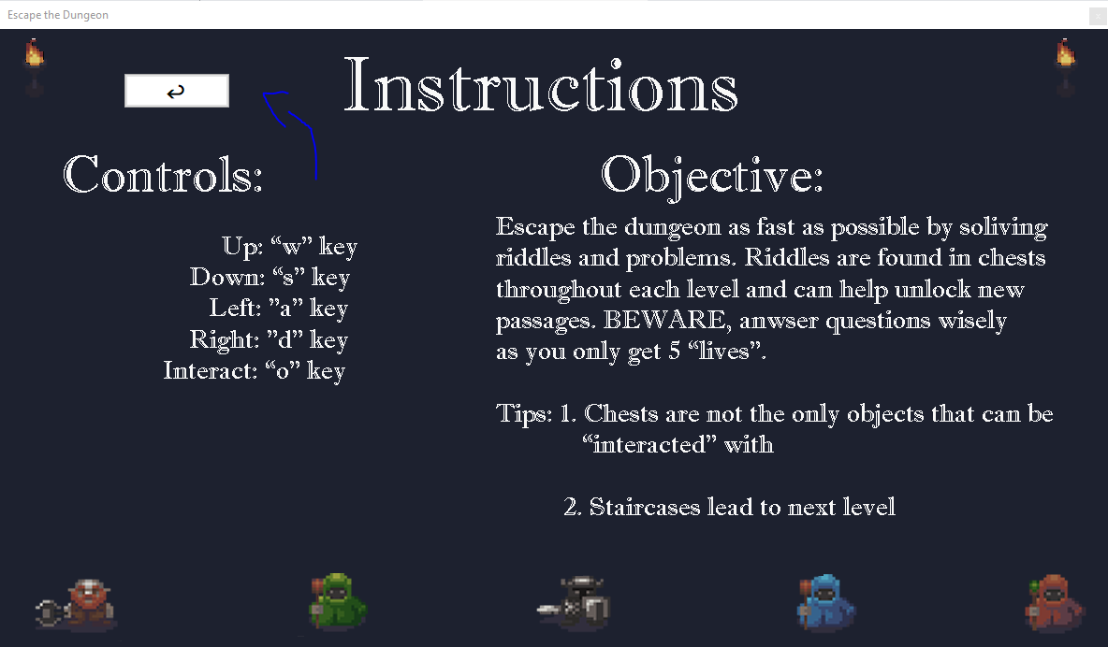Case #1:

Figure 2. Instructions

From this page the user may read the controls and objectives of the game. To return the main menu click arrow button as seen in this figure.

Case #2:

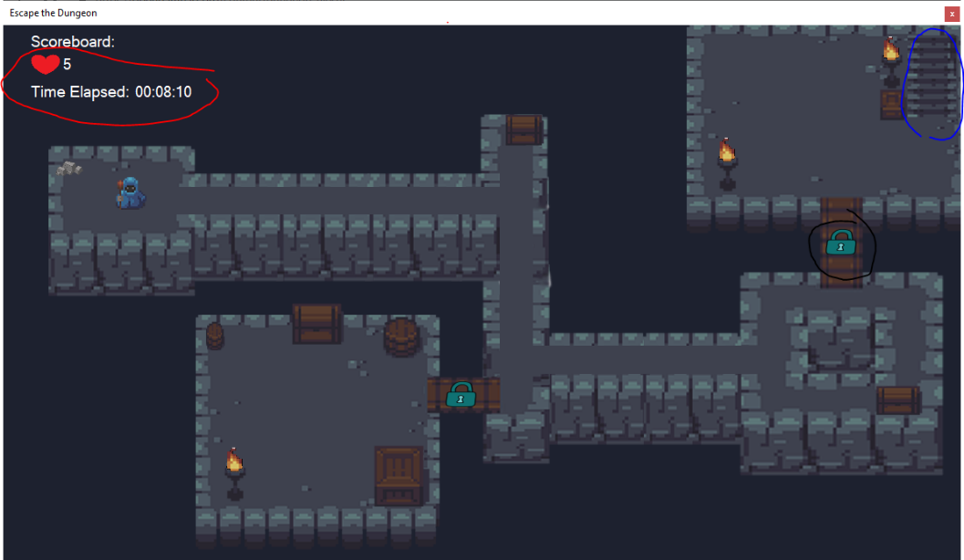

Figure 3. Level design

Blue: Staircases lead to the proceeding level.

Red: There are 2 elements to the scoreboard: Lives remaining and time elapsed.

Black: Sometimes passages will be locked and consequently will need to be unlocked via user’s ability to solve riddles/problems. Riddles are found in the chests located throughout the levels.

Interactable Objects:

Object interaction will either take form of a message box, or question box

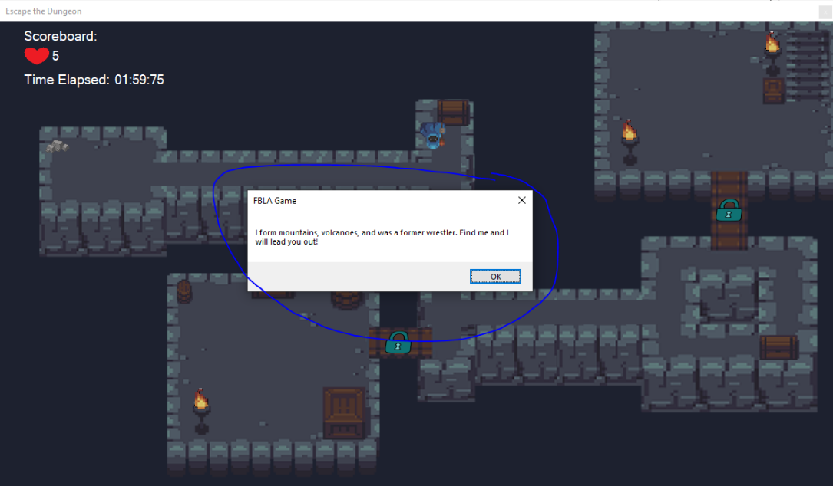Case #1:

Figure 4. message box

Blue: Message boxes do not require any user input. These will generally contain riddles that help user escape dungeon.

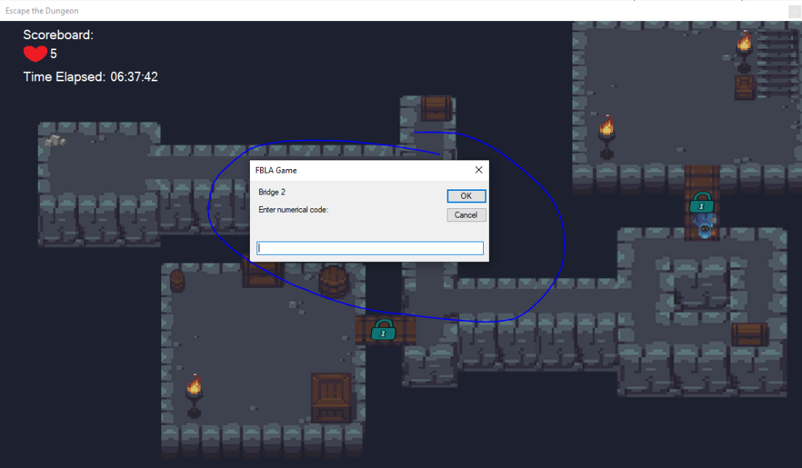Case #2

Figure 5. question box

Blue: Question boxes require user input, if user input does not meet respond requirements, a life will be lost.

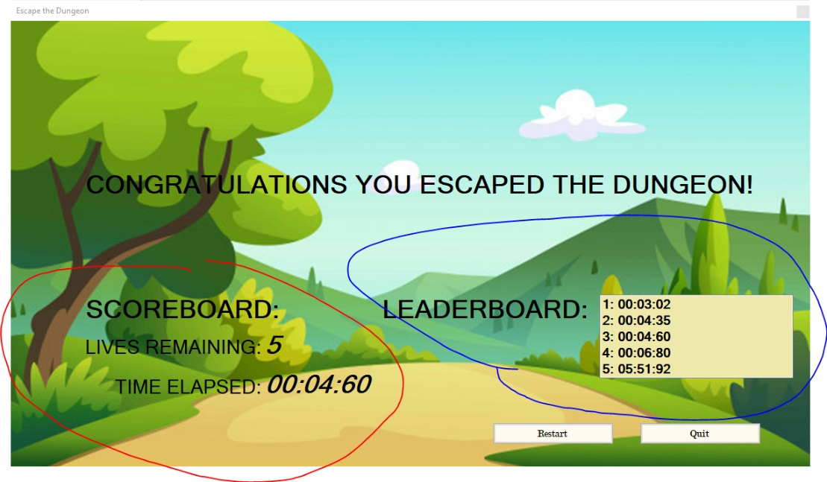Game end:

Figure 6. Game end screen

Red: Final score is displayed on the scoreboard

Blue: Time elapsed is compared with the previous times and is displayed on leaderboard

Class Libraries:

See “Class Library” in:

“FBLA Game-Escape the Dungeon” folder -> “Documentation” folder -> “Class Library.chm”

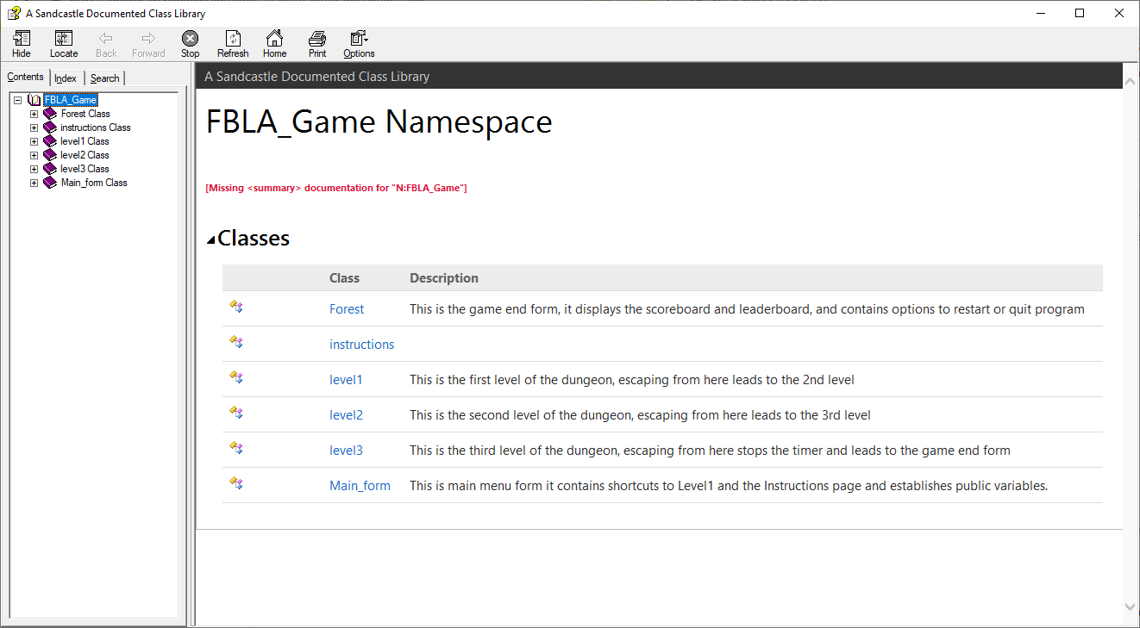

References:

Game art:

“Dungeon Tileset” designed by Buch - <https://opengameart.org/users/buch>

Creator:

Kwon Ryul Cha